For Other IITB department /External Users

### **C:\Users\Admin\AppData\Local\Packages\Microsoft.Windows.Photos_8wekyb3d8bbwe\TempState\ShareServiceTempFolder\logo.jpegभारतीय प्रौद्योगिकी संस्थान मुंबई**

### **INDIAN INSTITUTE OF TECHNOLOGY, BOMBAY**

**DEPARTMENT OF CHEMISTRY**

ANALYSIS REQUEST FORM –LCMS (Agilent 6545)

**User Type: IITB / External (University/National Lab/R & D/Industry)**

Name of the user:

Email:

Contact No:

Name of the Institute/Organization:

Detailed Address of Institute / Organization:

1. **Sample Code/Name:**

2. **Number of Samples:**

**Kindly Tick whichever is applicable for the following:**

3. **Analysis required**- Qualitative/Quantitative/both

4. **Details of Analysis required:**

5. **Expected compounds with empirical formula:**

6. **Sample Type:** Solid (Powder, Pellet, Bulk)/Liquid/ Dispersion/Emulsion/Colloidal/Gel/ /Others(Specify)

7. **Sample Category:** Biological (Microorganisms/ Fungal/Bacterial/ Protein/ blood/ Plasma/ Serum/Organs/ urine/Stool/ Cancerous Cells/Non Cancerous Cells/Plant Extracts/ Marine extracts)/Polymer/ Environmental/ Others (Specify)

8. **Sample volume/concentration/weight/specify concentration:**

9. **Solvents required**- ACN/ Methanol/ 2-Propanol/ Chloroform/ DCM/buffer/water others(specify)

10.**Sample nature:** Organic/ Inorganic/ Any other characteristic nature (Specify)

11. **Moisture:** Present/Absent/NA

12. **Volatile organic compound:** Present/ Absent/NA

13. **Stability of sample:** Stable, hygroscopic, sublimes, Reactive in air/moisture/ light/heat

14. **Specify the Storage and handling conditions:** (Room temp/ Refrigeration)

15. **Sample Properties:** Carcinogenic(carcinogenicity level-------) /Non Carcinogenic Radioactive/Explosive/ Toxic/ Corrosive/ Flammable/ Non flammable/ Other(specify)

16. **Toxicity:** Hazardous/ Non Hazardous

17. **Health hazards:** Yes/No (irritant to skin/irritant to eyes/harmful to skin/ toxic if inhaled/toxic if ingested)

18. **First aid measures:** Eye/Skin/Inhalation/ Ingestion/Others(specify)

19. **Disposal Method of sample :**

**NOTE :**All Samples will be discarded within 7 days of analysis. If you wish to collect the samples then you are required to make arrangement for the same.

20. **Additional information if any:**

21. **Label the sample(s)/ sample container(s) with hazard category:**

23. MSDS (should be uploaded/ attached if available):

24. Please fill in appropriate numbers in the NFPA diamond:

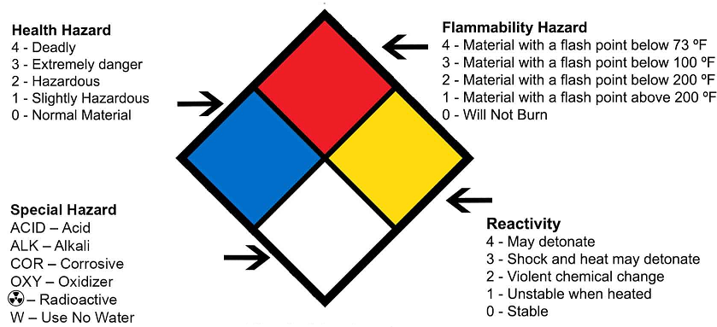

**Declaration:**

I confirm that the samples submitted for analysis are for research purpose only and the above furnished details are correct and true to the best of my knowledge. I understand that I will be held responsible for any damages arising from incorrect information provided by me against points 15-19.

I agree to acknowledge DST/FIST and Department of chemistry, IIT Bombay for providing (Instrument name) analytical facility for my research work, in my publications. I also agree to send the publication reference (Journal name/volume number/names of the authors/date of issue of the publication etc) to [rajeshg@chem.iitb.ac.in](mailto:rajeshg@chem.iitb.ac.in),

I declare that the “Content of this report is meant for our information only and we will not use the content of this report for advertisement, evidence, litigation or quote as certificate to third party” I accept that all the issued reports/results (Soft/hard) will not carry any Signature or Seal and Stamp of department of chemistry IIT Bombay.

Signature of the User Signature of the In Charge/HOD / P.I. / Guide

seal / stamp

Date:

Place: